GALLON KIT

YOU PICK ANY 4 COLORS
You will receive 2 PINTS with an applicator brush
of EACH color

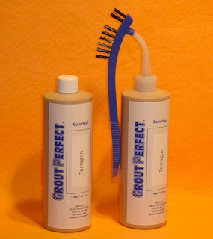
Type in color and Type in color and Type in color and Type in color and
manufacturer manufacturer manufacturer manufacturer

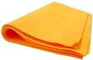
PLUS: (6) – 27” X 20” MicroFiber Shammy Sheets

MORE THAN A $325.00 VALUE
ALL THIS for the cost of 1 Gallon, only $222.50 + S&H

That’s enough GROUT PERFECT Grout ColorSeal to complete
approximately 4,000 square feet of tile floor based upon 12X12 tile and skill level.
That makes the ColorSeal cost about 5½¢ per square foot.

NAME | DATE
COMPANY NAME | BILLING ADDRESS
SHIPPING ADDRESS | BILLING CITY, STATE & ZIP CODE
SHIPPING CITY, STATE & ZIP CODE | CREDIT CARD NO.
PHONE | EXPIRATION DATE
E-MAIL | 3 OR 4 DIGIT SECURITY CODE
Either complete this order form online and e-mail to GPOrders@GroutPerfect.com or complete and fax to 877-767-3379. Void where prohibited. 7% sales tax will be applied to all Florida customers.

